1.1 COMPARISON:

|  |  |  |  |  |  |
| --- | --- | --- | --- | --- | --- |
| n → | 102 | 103 | 104 | 105 | 106 |
| Average number of comparisons during Quick Sort | 649 | 11042 | 156143 | 2013776 | 28232295 |
| 2nloge n | 921.03 | 13815.5 | 184206.81 | 2302585.09 | 27631021.12 |
| Average number of comparisons during Merge Sort | 541 | 8707 | 120452 | 1536369 | 18674209 |
| nlog2 n | 664.39 | 9965.78 | 132877.12 | 1660964.05 | 19931568.57 |

Inference- In both Merge sort and Quick sort, number of comparisons are of the same order (nlogn). But merge sort has lesser number of comparisons as compared to quick sort.

1.2 NUMBER OF COMPARISONS AND TIME COMPLEXITY OF QUICK SORT:

|  |  |  |  |  |  |
| --- | --- | --- | --- | --- | --- |
| n → | 105 | 3∗105 | 5∗105 | 7∗105 | 9∗105 |
| Average running time of Quick Sort | 18604 | 55628 | 95900 | 132540 | 173950 |

Graph-

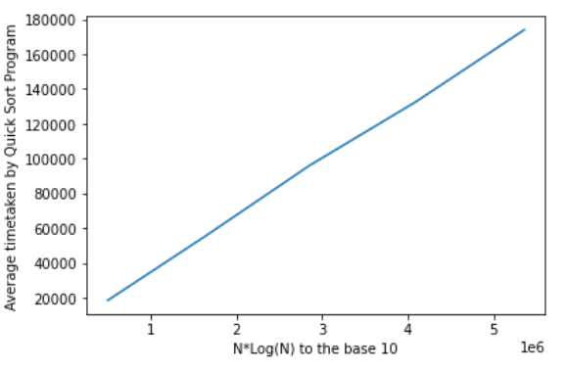

1.3 TIME COMPLEXITY:

|  |  |  |  |  |  |
| --- | --- | --- | --- | --- | --- |
| n → | 102 | 103 | 104 | 105 | 106 |
| Average running time of Quick Sort | 16 | 164 | 1692 | 18604 | 196654 |
| Average running time of Merge Sort | 62 | 230 | 2848 | 36658 | 360598 |
| Number of times Merge Sort outperformed Quick Sort | 1 | 0 | 1 | 0 | 0 |

Graph-

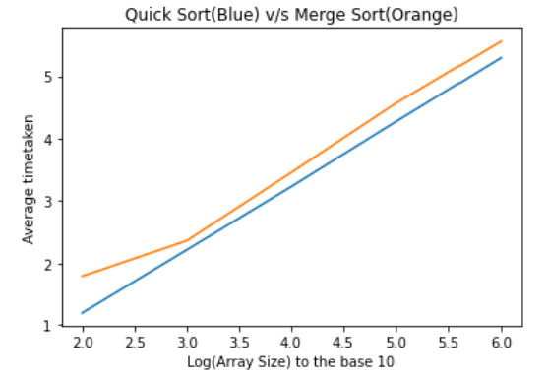

Inference- Average running time of Quick Sort is less than Merge Sort. Therefore there exist built in functions or algorithm in a language for Quick Sort which is not the case with Merge Sort.

1.4 RUNNING TIME OF THE QUICKSORT WITH IMPROVED-MERGE-SORT:

|  |  |  |  |  |  |
| --- | --- | --- | --- | --- | --- |
| n −→ | 102 | 103 | 104 | 105 | 106 |
| Average running time of Quick Sort | 16 | 164 | 1692 | 18604 | 196654 |
| Average running time of Merge Sort | 18 | 172 | 1768 | 21174 | 223651 |
| Number of times Improved-Merge-Sort outperformed Quick Sort | 0 | 0 | 0 | 0 | 0 |

Graph-

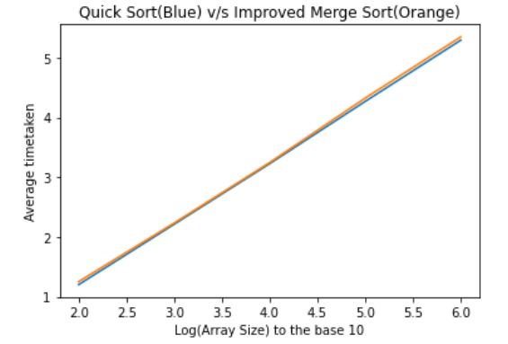

2. RELIABILITY OF QUICK SORT:

|  |  |  |  |  |  |
| --- | --- | --- | --- | --- | --- |
| n −→ | 102 | 103 | 104 | 105 | 106 |
| Average running time of Quick Sort | 16 | 164 | 1692 | 18604 | 196654 |
| No. of cases where run time exceeds average by 5% (0-5%) | 0 | 0 | 0 | 0 | 0 |
| No. of cases where run time exceeds average by 10% (5-10%) | 0 | 0 | 0 | 84 | 101 |
| No. of cases where run time exceeds average by 20% (10-20%) | 2 | 3 | 408 | 3 | 7 |
| No. of cases where run time exceeds average by 30% (20-30%) | 0 | 1 | 0 | 1 | 2 |
| No. of cases where run time exceeds average by 50% (30-50%) | 1 | 0 | 0 | 2 | 0 |
| No. of cases where run time exceeds average by 100% (50-100%) | 0 | 0 | 0 | 0 | 0 |

Inference- The data is case dependent so we could not say about the certainty of the data. So no inference can be draw.